

**Lab Manual- Docker Volume**

**Prepared for**:

**Date:** 18th Dec 2023

**Prepared by:**

Document Name: Lab Manual **Document Number** AZLabn910

**Contributor:**

Contents

1. Objective 2

2. Create Volume 3

3. Inspect Volume 3

4. Start a container with a volume 4

5. Mount the Volume in New container 5

6. Remove the Volume 6

# Objective

Docker volumes are a widely used and useful tool for ensuring data persistence while working in containers. Docker volumes are file systems mounted on Docker containers to preserve data generated by the running container.

Docker has two options for containers to store files in the host machine so that the files are persisted even after the container stops:

1. **Volumes** are stored in a part of the host filesystem, which is managed by
2. **Bind mounts**may be stored *anywhere* on the host system.

The volumes are stored on the host, independent of the container life cycle. This allows users to back up data and share file systems between containers easily.

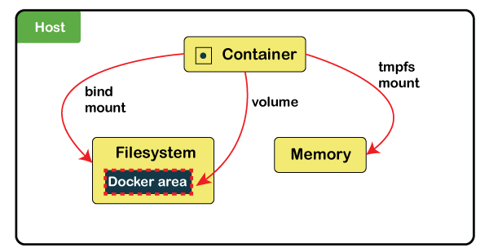

# Create Volume

* **Step1:** Use the following command to create and manage Docker volumes outside the scope of any container.

docker volume create data



# Inspect Volume

* It lists all the details of a volume, including its location on the host file (mountpoint), and everything stored within the data volume can also be found in the directory listed under the mountpoint path. Use the following command to inspect a volume.

docker volume inspect data

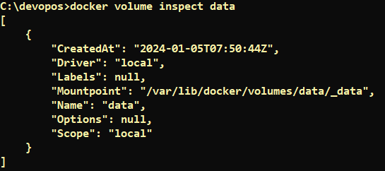

# Start a container with a volume

* The **-v** examples below map the data volume inside ubuntu container data foleder

docker run -it --name demo6 -v data:/data ubuntu bash

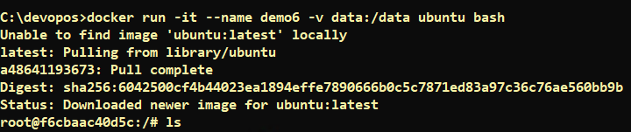

* Now you are inside container. Lets create two file in this volume

root@f6cbaac40d5c:/# ls

bin boot data dev etc home lib lib32 lib64 libx32 media mnt opt proc root run sbin srv sys tmp usr var

root@f6cbaac40d5c:/# ls data

root@f6cbaac40d5c:/# touch data/test.txt

root@f6cbaac40d5c:/# touch data/test2.txt

root@f6cbaac40d5c:/# ls data

test.txt test2.txt

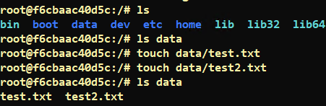

* Now exit

exit



* Now Remove the container

docker system prune



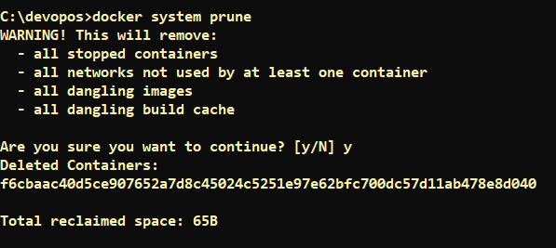

# Mount the Volume in New container

* Now Let’s test the volume with new container

docker run -it --name demo7 -v data:/data ubuntu bash

ls data

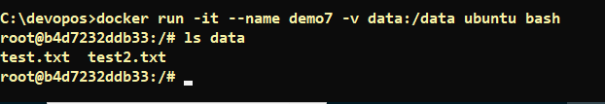

* Exit and remove container

exit

docker system prune

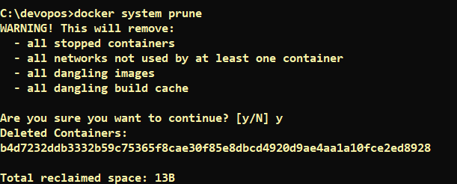

* Check we still have volume

docker volume ls



# Remove the Volume

* Now Remove the volume

docker volume rm



* Confirm Volume removed

docker volume ls

